


Pen Powerhouse In Hand Manipulation Exercises 2
You will need a pen or pencil and some coins for these exercises.
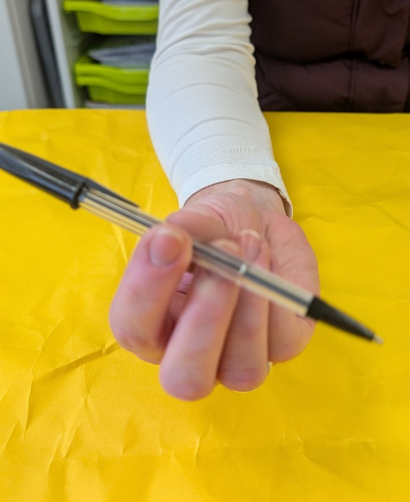
Activity 9
- Hold a pen or pencil between your thumb, index and middle fingers.

- Rotate in one direction 5 times.

- Rotate in the opposite direction 5 times.

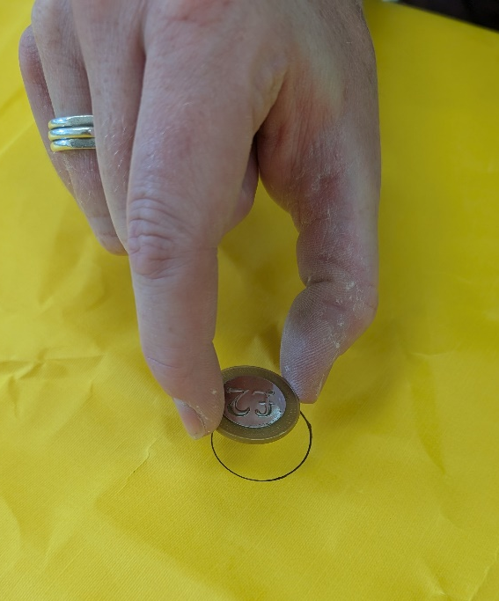
- Hold a coin between your thumb, index and middle fingers.

- Place it carefully into a circle shape on a piece of paper

- Increase to holding 2 coins and placing them in the circle.

- Try with 3, 4 and 5 coins, making sure they remain stacked when placed.
2
1

