


Pen Powerhouse In Hand Manipulation Exercises 1
Activity 8
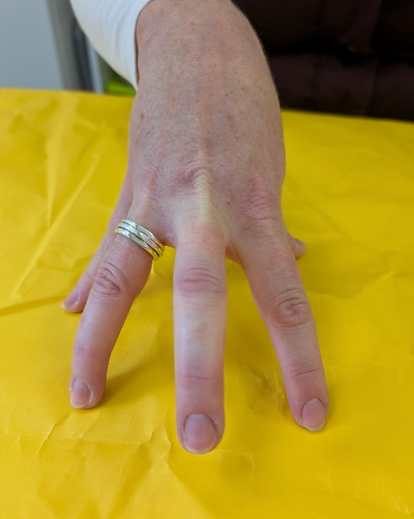
- Place your hand flat on the table.

- Keep forearm on the table and lift knuckles to make a tent.

- Lift each finger in turn while keeping other fingers on the table.

- Repeat 5 times with each finger.

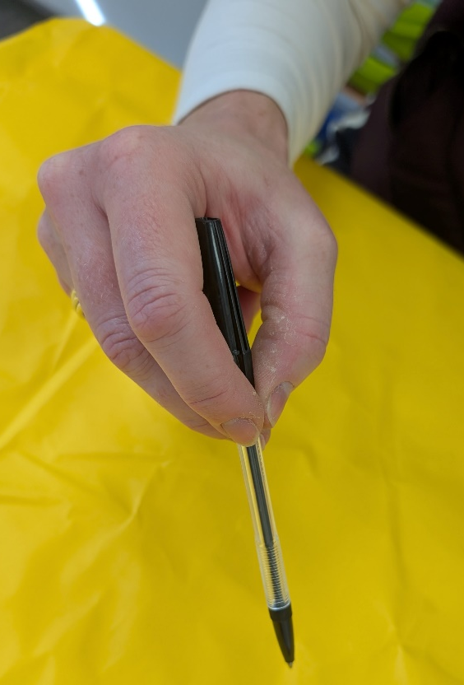
2
- Hold a pen or pencil in a writing position.

- Walk your fingers up to the other end.

- Flip the pencil over so you are again in a writing position.

- Repeat 5 times.
1

