


Pen Powerhouse Hand and Finger Exercises
Activity 7
- Spread your fingers out and place your hands on the table like you are about to play the piano.

- Move each finger up and down in sequence.

- Create your own sequences and / or mirror with each hand.
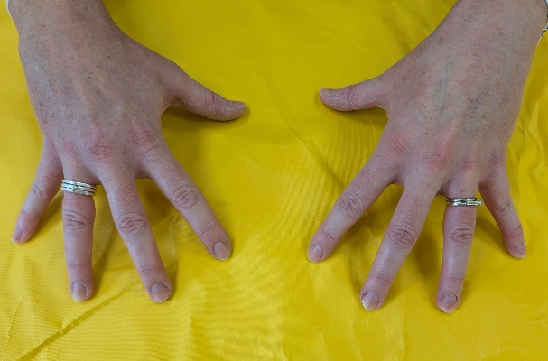
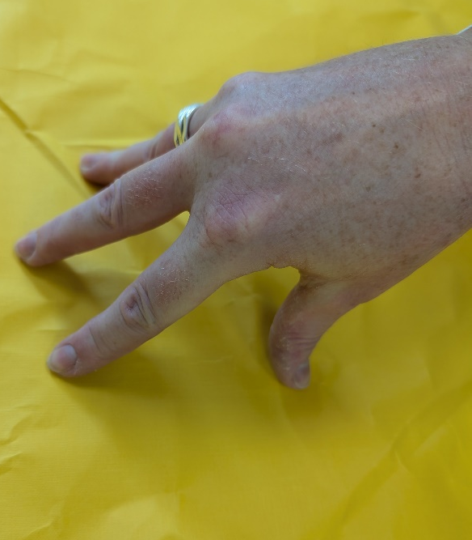
1
2
- Spread your fingers and place on the table.

- Keeping your fingers and thumb in contact with the table, bring them together to do “spider push-ups”.

- Repeat 3 sets of 5.

