


Pen Powerhouse Hand and Finger Exercises
Activity 6
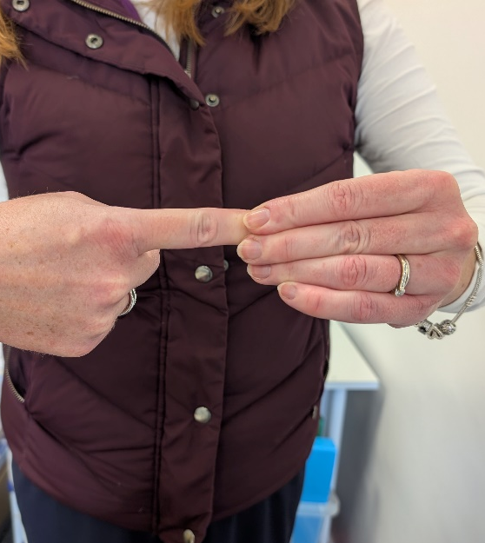
- Gently grip the end of your finger with your other finger and thumb.

- Gently push the finger back into itself.

- Repeat for each finger on each hand.

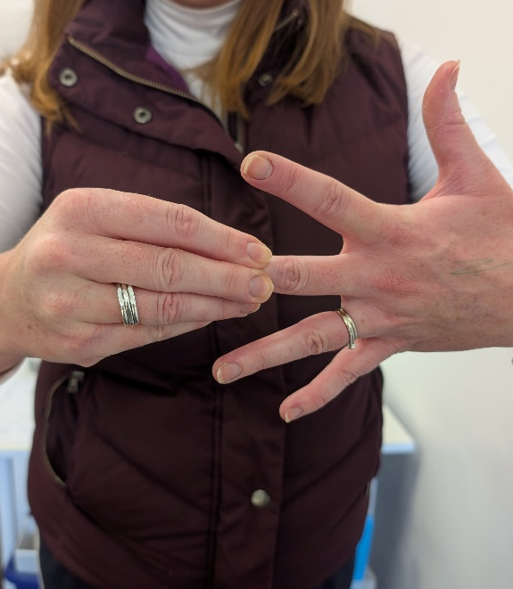
1
2
- Starting at the base of the finger, pull along the finger from palm to tips.

- Repeat for each finger so you are taking off “magic writing gloves”.

