The course is made up as follows:

Listening: 3 x externally set assignments (25%)

Reading: 3 x externally set assignments (25%)

Speaking: 1 x compulsory externally set role-play and 2 x internally set assignments (25%)

Writing: 1 x compulsory externally set translation and 2 x internally set assignments (25%)

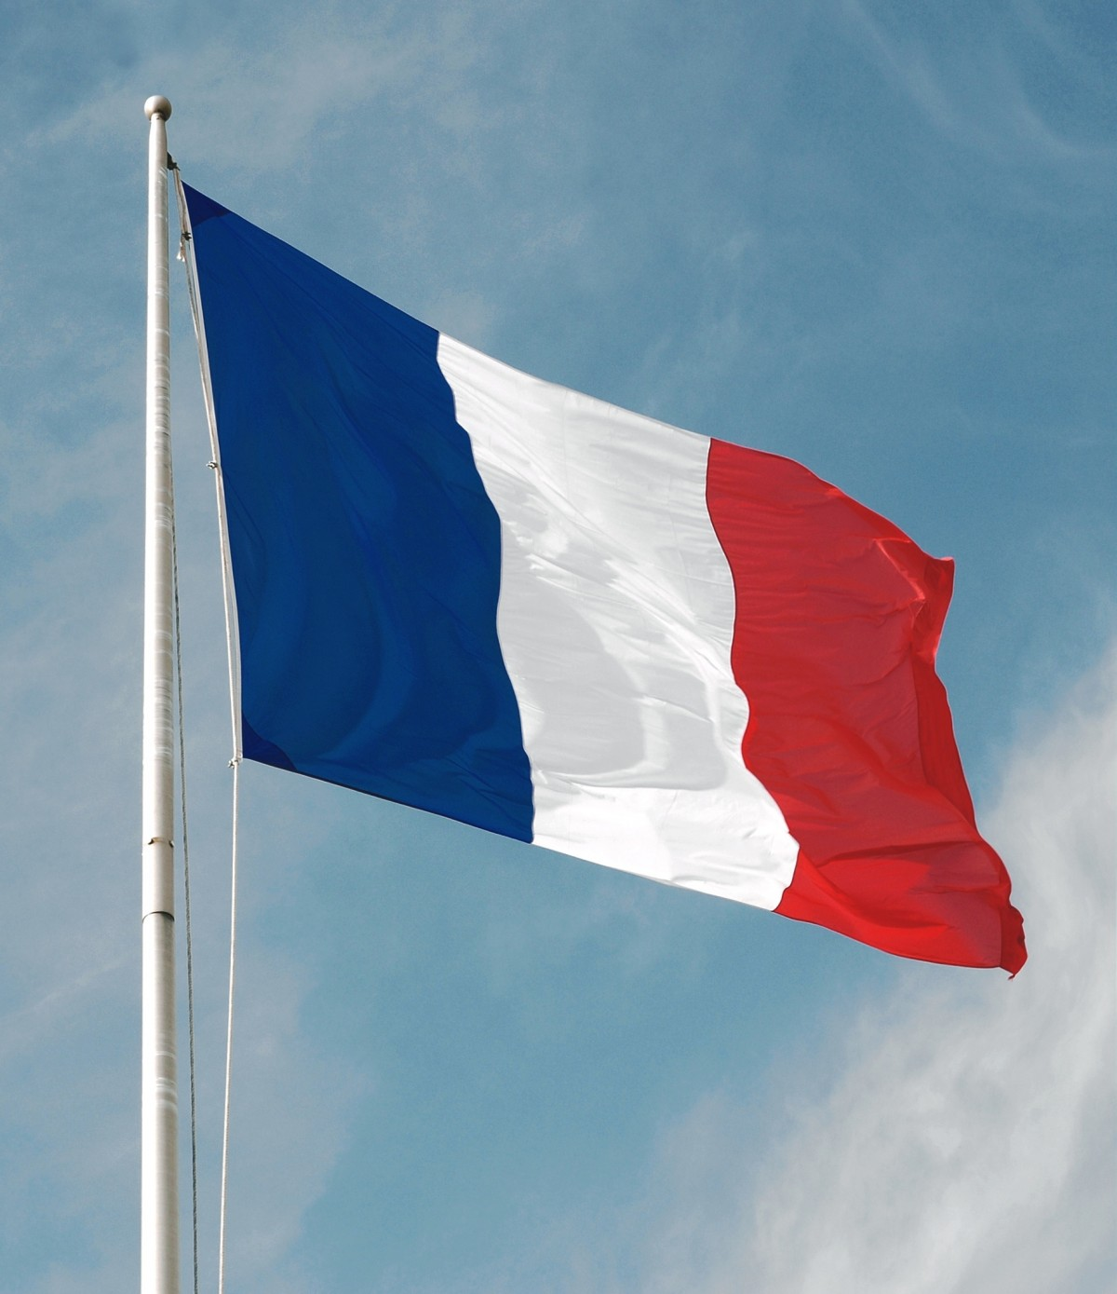


Course description
AQA FCSE French is a two year modular course which aims to nurture and develop students’ understanding, usage and love of the French language.
- Covers all four skill areas: Listening; Speaking; Reading and Writing

- Is suitable for a broad range of abilities

- Provides and incentive for learners of languages, increasing motivation and engagement in the subject area..

- Has 3 levels of award: Pass, Merit, Distinction

- Provides students with an introduction to simple translation from English into French (Writing), from French into English (Reading) and role-play (Speaking).

