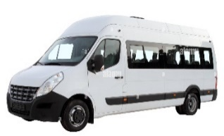


Corley Transport
Code of Conduct

- Always Follow the Driver & Passenger Assistants’ instructions.
- Enter the bus and take your seat.
- Face forward and put on your seatbelt.
- No eating, you can only drink water if needed. It is safer to drink when the bus has stopped.
- Do not touch others in front beside or behind you.
- Do not open the windows. The Passenger Assistant will do this.
- Keep your arms and all other objects inside the bus.
- Keep your voice and noise at a low level as not to distract the driver.
- No bullying or being unkind to others.
- No shouting or using offensive language.
- No physical aggression to others.
- Take pride in your bus, keep it safe and clean.

Passenger Transport

